Peace Talk!
Honoring Gwynedd’s Peace Pole which says ‘May Peace Prevail on Earth’ in 4 languages
December includes several holidays that bring light to a dark time of year. December 10th is Human Rights Day, the 75th anniversary of the signing of the UN Universal Declaration of Human Rights. The theme this year is Dignity, Freedom and Justice for All.
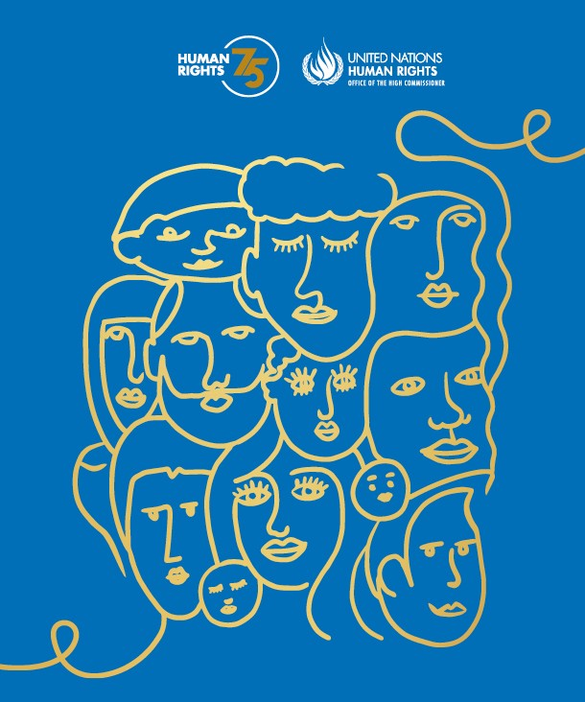
Many people in the world treasure this month as a time to give generously to those in need, to work toward world peace, and to fully demonstrate love for family. In the state of New York, the government decided to make December Peace Month. It is a call for every person to be peaceful, respectful and responsible to others. This too is a way to shine light into the darkness of hate and intolerance.
Activity #1
Watch/listen to ‘Light a Candle for Peace’. Join in singing it by yourself or with family or friends. You can even try to do it with the harmony!
https://www.youtube.com/watch?v=K9M8SmWh2Fo

Activity #2
Try a Peace Family Dinner in which the goal is to create true harmony. State out loud if you forgive a family member for any hurt you feel from them. Think of new ways you can play and work with each person to peacefully coexist. Think creatively about new activities to share that make each family member feel peaceful and included.
Activity #3
When you give to others and let your light shine, how do your body and brain respond? Try drawing what it looks and feels like to enter a peaceful, full-of-light state of being.
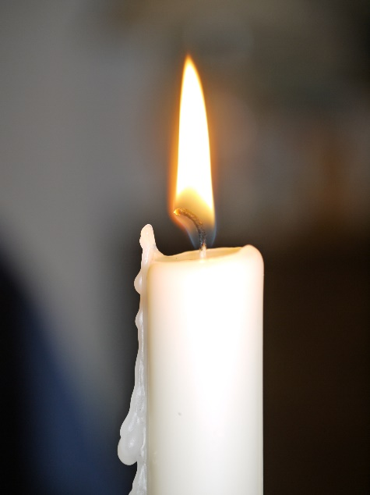
Activity #4
Join others from Gwynedd Friends Meeting on Wednesdays at 6:30 PM as we vigil for a ceasefire in Gaza. More wars and weapons won’t bring peace – protect the lives of the hostages and all civilians – there are roughly 1 million children in Gaza. Bring LED candles, flashlights or other forms of illumination you can safely control. We will be on the corner of Sumneytown Pike and 202.

From the Peace & Social Action Committee

